A

MINI PROJECT II REPORT
ON

TITLE OF PROJECT

SUBMITTED BY

<NAME OF STUDENTS>

UNDER THE GUIDANCE OF <NAME OF GUIDE>


DEPARTMENT OF COMPUTER SCIENCE AND ENGINEERING P.N.E.S.P.’S
NAGESH KARAJAGI ORCHID COLLEGE OF ENGG. & TECH SOLAPUR – 413 002


AFFILIATED TO
DR.BABASAHEB AMBEDKAR TECHNOLOGICAL UNIVERSITY LONERE A. Y. 2025-2026
i

CERTIFICATE

This is to certify that the mini project entitled Title of Project has been completed by following students of Third year (CSE) class in a satisfactory manner under my guidance.

Name of student1
Name of student2
.
.

The mini project is found to be complete in partial fulfillment for the award of Degree of Bachelor in Computer Science & Engineering of Dr. Babasaheb Ambedkar Technological University, Lonere.

(Guide Name) | (Dr. V. V. Bag) | (Dr. B. K. Sonage)
PROJECT GUIDE | HOD | PRINCIPAL


DEPARTMENT OF COMPUTER SCIENCE AND ENGINEERING P.N.E.S.P.’S

NAGESH KARAJAGI ORCHID COLLEGE OF ENGG. & TECH SOLAPUR – 413 002

AFFILIATED TO
DR.BABASAHEB AMBEDKAR TECHNOLOGICAL UNIVERSITY LONERE A.Y. 2025-2026

ii

Code of Ethics for Plagiarism
- We know that plagiarism means taking and using the ideas, writings, works or inventions of another person as if they were one’s own. We know that plagiarism not only includes verbatim copying, but also the extensive use of another person’s ideas without proper acknowledgement (which includes the proper use of quotation marks). We know that plagiarism covers this sort of use of material found in textual sources and from the Internet.

- We acknowledge and understand that plagiarism is wrong.

- We understand that my research must be accurately referenced. We have followed the rules and convention concerning referencing, citation and the use of quotation as set out in the Departmental Guide.

- This project work is our own work, or our group’s unique group project work. We acknowledge that copying someone else’s work or part of it, is wrong, and that submitting identical work to others constitutes a form of plagiarism.

- We have not allowed, nor will We in the future allow, anyone to copy our work with the intention of passing it off as their own work.

………………..

………………

………………

………………..

(Name & Signature of the Student/s)

Place: NKOCET, Solapur Date:

iii

DECLARATION

By the UG (B. Tech) Student

We hereby declare that the Report of the Mini Project Work Title of project. Which is being submitted to the Dr. Babasaheb Ambedkar Technological University, Lonere in Partial ful-fillment of the requirements for the award of the Degree Bachelor of Technology in the department of Computer Science and Engineering , is a bonafide report of the work carried out by us. The material contained in this report has not been submitted to any University or Institution for the award of any degree.

(Name & Signature of the Student/s)

Place: NKOCET, Solapur Date

iv

PROJECT APPROVAL SHEET

The mini project entitled Title of Project submitted by the following students –

Name of student1
Name of student2
.
.

is hereby approved in partial fulfillment for the award of Degree of Bachelor in Computer Science & Engineering of Dr. Babasaheb Ambedkar Technological University, Lonere.

EXAMINERS

1. External Examiner

2. Internal Examiner

DEPARTMENT OF COMPUTER SCIENCE AND ENGINEERING P.N.E.S.P.’S

NAGESH KARAJAGI ORCHID COLLEGE OF ENGG. & TECH SOLAPUR – 413 002

AFFILIATED TO
DR.BABASAHEB AMBEDKAR TECHNOLOGICAL UNIVERSITY LONERE A.Y. 2025-2026

ACKNOWLEDGEMENT

I am thankful to the Department of Computer Science & Engineering, Nagesh Karajagi Orchid College of Engineering & Technology, Solapur for giving me the opportunity to undertake a project in their organization. We would like to mention our sincere gratitude towards our Principal Dr. B.K.Sonage and H.O.D Dr. V.V.Bag, Computer Science and Engineering Department, for giving us this opportunity to carry out this project. I take this opportunity to express my sincere thanks to our guide <NAME OF GUIDE> for his guidance and encouragement. I am thankful to our guide for his guidance at every step throughout my project report. Finally I take this opportunity to mention my sincere thanks to one and all those who helped us directly and indirectly in the completion of this project report.

Name of student1
Name of student2
.
.

vi

ABSTRACT

Abstract of the report to be given here. Please restrict to a maximum of 200 words. NOTE: The abstract should not have any citations, or abbreviations, nor should it be divided into sections. It can be divided into adequate number of paragraphs as the author wishes. It is advisable to avoid any equations in the Abstract. Figures and tables are to be avoided.
Note that all paragraphs in the Abstract start with an indent of 15 mm, and there is no extra spacing between two successive paragraphs. The text should be Times New Roman font size 12, single spaced

vii

Index
CERTIFICATE ii
Code of Ethics for Plagiarism …………………………………………………iii
DECLARATION iv
PROJECT APPROVAL SHEET ……………………………………………...v
ACKNOWLEDGEMENTS vi
ABSTRACT ……………………………………………………………………vii
LIST OF FIGURES x
LIST OF SCREENSHOTS xi
CHAPTER 1 : INTRODUCTION
  - General Introduction 1
  - Literature Review… 2
  - Problem of Existing System… 3
  - Summary……….. 3
CHAPTER 2 : PROPOSED WORK
  - General Introduction………………………………………… 4
  - Motivation……………….. 4
  - Objective…………… 4
  - Proposed System… 5
  - Scope…………. 5
  - Project Analysis… 5
  - Summary…….. 5
CHAPTER 3 : REQUIREMENTS ANALYSIS AND SRS PREPARATION
  - General Introduction………………………………………… 4
  - Software Requirement Specification… 6
  - Constraint……… 6
  - Functional Requirements… 6
  - Interfaces……….. 7
  - Other Requirements 9
  - Summary…….. 9

CHAPTER 4 : DETAILED DESIGN
  - General Introduction……………………………………….10
  - ER Diagram… 10
  - Use Case Diagram 10
  - Sequence Diagram… 11
  - Class Diagram… 12
  - Summary……. 13

CHAPTER 5: PROPOSED METHODOLOGY

General Introduction………………………………………….15
  - Proposed Project Model … 16
4.3 Use Case Diagram 17

CHAPTER 6: RESULTS AND DISCUSSION
6.1 presentation of results using suitable figures, graphs and charts. Different test scenarios should be clearly explained along with results

CHAPTER 6 : CONCLUSION
  - Conclusion… 26
6.2 Future Scope 26

REFERENCES 27

LIST OF FIGUREs

FIGURE | TITLE | PAGE NUMBER
1.1. | Schematic diagram showing the proposed mechanism | 5
1.2. | Next figure alpha | 9
2.1. | Next figure beta | 35
2.2. | Next figure gamma | 39
3.1. | Next figure alpha, alpha | 46
4.1. | Plot of concentration vs time | 120
5.1. | Next figure beta, beta | 310

x

LIST OF TABLES

TABLE | TITLE | PAGE NUMBER
1.1. | Percentage composition of fuel components | 11
1.2. | Name of Table delta | 12
2.1. | Name of Table gradient | 35
4.2. | Name of Table alpha | 100
5.1. | Kinetic parameters calculated for the system | 310

xi

Sample Report

NOTE: Number every page with numericals (e.g. 1,2,3…)
Align to down right corner (sample refer on Introduction page)

CHAPTER ONE

INTRODUCTION

  - General Introduction

In the modern digital era, images have become an integral part of information exchange across various platforms, ranging from social media to confidential communications in medical and legal fields. As the volume and sensitivity of image data proliferate, so do the threats to their security. Unauthorized access, data breaches, and tampering with digital images can lead to severe privacy violations, financial losses, and legal repercussions. Hence, ensuring the confidentiality, integrity, and authenticity of image data is paramount.
Encryption is a fundamental technique employed to protect digital data from unauthorized access. Among the various encryption algorithms available, the Triple Data Encryption Standard (Triple DES) stands out due to its robust security features. Triple DES, an enhancement of the original DES algorithm, applies the DES cipher algorithm three times to each data block, significantly increasing its resistance to cryptographic attacks.
This project aims to leverage the strength of Triple DES to secure digital images. By implementing Triple DES for image encryption and decryption, we seek to ensure that images remain confidential and unaltered during storage and transmission. The project will delve into the technical aspects of the Triple DES algorithm, its application in image security, and an evaluation of its performance in terms of encryption and decryption speed, impact on image quality, and resilience against various cryptographic attacks.
Furthermore, this project will compare Triple DES with other encryption algorithms to highlight its effectiveness and limitations in the context of image security. The ultimate goal is to provide a comprehensive understanding of how Triple DES can be employed to enhance the security of digital images, thereby contributing to the broader field of data security in the digital age.

  - Literature Review

The importance of image security in the digital age cannot be overstated. As images are extensively used across various domains such as social media, medical imaging, legal documentation, and secure communications, protecting this data from unauthorized access and tampering has become a critical concern. This literature review examines the evolution of cryptographic techniques for securing digital images, with a focus on the Triple Data Encryption Standard (Triple DES) algorithm and its application in image encryption.
Early Encryption Techniques
The inception of digital encryption began with simple substitution and transposition ciphers. However, these techniques were soon found inadequate for modern security requirements due to their vulnerability to various forms of cryptanalysis. As computational capabilities advanced, more sophisticated algorithms such as the Data Encryption Standard (DES) were developed. DES, introduced by IBM in the 1970s, became a widely accepted standard for data encryption, employing a 56-bit key to secure data.
The Evolution to Triple DES

1

Despite its initial success, DES was eventually found to be insufficient against brute-force attacks due to its relatively short key length. To address this vulnerability, Triple DES (3DES or TDES) was developed. Triple DES enhances security by applying the DES algorithm three times with either two or three keys, effectively extending the key length to 112 or 168 bits, respectively. This approach significantly increases the difficulty of cryptographic attacks, making Triple DES a more robust option for securing sensitive data.
Triple DES in Image Security
Numerous studies have explored the application of Triple DES in securing image data. Elminaam et al. (2010) investigated the performance of various encryption algorithms, including Triple DES, in terms of encryption speed, throughput, and security level. Their findings indicated that while Triple DES offers enhanced security, it comes with a computational overhead that affects its encryption and decryption speed compared to other algorithms like Advanced Encryption Standard (AES).
Comparisons with Contemporary Algorithms
While Triple DES has been a reliable choice for securing data, newer algorithms like AES and RSA have also gained prominence. AES, for instance, offers faster processing times and stronger security with variable key lengths of 128, 192, and 256 bits. In contrast, RSA, an asymmetric encryption algorithm, provides robust security but is less efficient for large data sets like images due to its computational complexity.
Practical Implementation and Performance
Practical implementations of Triple DES in image security have demonstrated its feasibility and effectiveness. For instance, Muniandy et al. (2016) implemented Triple DES for encrypting medical images, ensuring patient confidentiality and data integrity during transmission. The study emphasized the importance of secure key management practices to prevent unauthorized access and maintain the robustness of the encryption scheme.

Problem Of Existing System

In the realm of digital image security, existing systems face several critical challenges that compromise the confidentiality, integrity, and authenticity of image data. These challenges stem from inherent limitations in older encryption algorithms, evolving threat landscapes, and the increasing demand for efficient processing in real-time applications. This section outlines the primary problems associated with existing image security systems.

Summary

The problems associated with existing image security systems highlight the need for more robust, efficient, and adaptable encryption solutions. While legacy systems have laid the groundwork for digital security, their limitations in terms of security, performance, compatibility, key management, flexibility, and scalability underscore the necessity for ongoing innovation. By addressing these challenges, the implementation of more advanced encryption algorithms like Triple DES can significantly enhance the security and efficiency of image data protection, ensuring the confidentiality and integrity of sensitive information in an increasingly digital world.

2

Motivation

CHAPTER TWO PROPOSED WORK

The exponential growth of digital media and the increasing reliance on image data for communication, documentation, and various professional applications underscore the critical need for robust image security. In sectors such as healthcare, legal services, finance, and social media, the protection of image data is paramount to ensure privacy, prevent unauthorized access, and safeguard the integrity of information. This project is driven by several key motivations: Increasing Threats to Image Data
The digital age has brought about a proliferation of cyber threats that target image data. These threats include unauthorized access, data breaches, image tampering, and theft of sensitive information. With the rising incidence of cyber-attacks, the vulnerability of unprotected image data poses significant risks. The motivation to enhance image security stems from the need to mitigate these risks and protect users' privacy and sensitive information.
Limitations of Existing Security Systems
Existing image security systems often rely on outdated encryption algorithms or face significant challenges related to computational efficiency, key management, and adaptability. Legacy systems like DES have proven insufficient in the face of modern cryptographic attacks, while even more advanced systems like Triple DES can struggle with performance issues. This project is motivated by the desire to address these limitations, providing a more secure and efficient solution for image encryption.

Objective

The primary objective of this project is to implement and evaluate the Triple Data Encryption Standard (Triple DES) algorithm for securing digital images. This objective can be broken down into several specific goals:

4

Implement Triple DES for Image Encryption and Decryption:
      - Develop a software solution to apply the Triple DES algorithm for encrypting and decrypting digital images.
      - Ensure that the implementation correctly adheres to the cryptographic standards and specifications of Triple DES.

Evaluate the Security of Triple DES:
      - Assess the effectiveness of Triple DES in protecting image data from unauthorized access and tampering.
      - Analyze the algorithm’s resistance to common cryptographic attacks, including brute-force, differential, and linear cryptanalysis.

Analyze the Performance of Triple DES:
      - Measure the encryption and decryption speed of Triple DES when applied to digital images of varying sizes and formats.
      - Evaluate the computational overhead and resource requirements associated with using Triple DES.

Proposed System

The proposed system for our Image security by Triple DES Algorithm to address the challenges associated with digital image security, this project proposes the implementation and evaluation of the Triple Data Encryption Standard (Triple DES) algorithm for encrypting and decrypting digital images. The proposed solution aims to leverage the robustness of Triple DES to ensure the confidentiality, integrity, and authenticity of image data. The solution will be developed and assessed through a series of steps designed to achieve the project’s objectives.

Scope
The scope of this project encompasses the comprehensive development, implementation, and evaluation of the Triple Data Encryption Standard (Triple DES) algorithm for securing digital images. This includes several specific tasks and activities designed to achieve the project’s objectives. The scope is delineated into the following key areas:

Project Analysis

The analysis of this project focuses on the practical implementation and evaluation of the Triple Data Encryption Standard (Triple DES) algorithm for securing digital images. This analysis is structured around several key dimensions: functionality, security, performance, usability, and real-world applicability. Each dimension is critically examined to assess the strengths, limitations, and overall efficacy of the proposed solution.

Summary

This chapter introduces the motivation for this application and explains how the new system overcomes the problem of the existing system.

5

CHAPTER THREE

REQUIREMENTS ANALYSIS AND SRS PREPARATION

Software Requirements Specification
The development and implementation of the Triple Data Encryption Standard (Triple DES) for securing digital images require a comprehensive set of software requirements. These requirements ensure the system's functionality, security, performance, usability, and compatibility. The following outlines the essential software requirements for this project:

Functional Requirements

Image Encryption and Decryption:

  - The system shall provide functionality to encrypt and decrypt digital images using the Triple DES algorithm.
  - The system shall support various image formats, including JPEG, PNG, and BMP.
  - The system shall convert images into a byte array for encryption and reassemble the byte array back into the original image format after decryption.

User Interface:

  - The system shall offer a graphical user interface (GUI) for users to easily upload, encrypt, and decrypt images.
  - The interface shall include options for users to select the image file, start the encryption/decryption process, and save the processed image.

Key Management:

  - The system shall generate, store, and manage encryption keys securely.
  - The system shall support the use of 112-bit and 168-bit keys for Triple DES encryption.

Feedback and Reporting:

  - The system shall provide real-time feedback on the encryption/decryption status to the user.
  - The system shall generate logs for encryption and decryption activities, including timestamps and success/failure status.

Security Requirements Data Protection:
  - The system shall use Triple DES encryption to protect image data from unauthorized access and tampering.

  - The system shall ensure that encryption keys are stored securely and are not accessible to unauthorized users.

Authentication and Authorization:

  - The system shall require user authentication before allowing access to encryption and decryption functionalities.
  - The system shall implement role-based access control (RBAC) to restrict access based on user roles.

Integrity Checks:

  - The system shall perform integrity checks to ensure that the decrypted image matches the original image without any loss or alteration of data.

Performance Requirements Processing Speed:
  - The system shall optimize the encryption and decryption processes to minimize processing time for images of varying sizes.
  - The system shall aim to complete encryption and decryption operations within a reasonable timeframe, considering the computational overhead of Triple DES.

Resource Utilization:

  - The system shall efficiently manage CPU and memory resources to handle large image files without significant performance degradation.
  - The system shall implement techniques to optimize resource usage, such as parallel processing or hardware acceleration where applicable.

  - Constraints

The development and implementation of the Triple Data Encryption Standard (Triple DES) for securing digital images are subject to several constraints. These constraints can impact the project's design, development, and deployment phases and need to be carefully managed to ensure successful completion. The following outlines the primary constraints for this project:

FUNCTIONAL REQUIREMENT
The functional requirements for implementing Triple Data Encryption Standard (Triple DES) for securing digital images ensure the system performs as intended. These requirements cover the core functionalities needed to encrypt and decrypt images, manage keys, provide user interaction, and maintain security.
6

INTERFACES

    - Hardware Interface
Server Side: PHP
Client-Side: Any Desktop (Having any operating system).

Software Interface
Front End: Html ,Css
Backend : Encryption Decryption

The software interface requirements for the project outline the interaction between users and the software components of the Triple Data Encryption Standard (Triple DES) system for securing digital images. This includes the design and functionality of the graphical user interface (GUI), command-line interface (CLI) options, and integration with other software systems.
Graphical User Interface (GUI)

Home Screen:
Navigation Menu: Options to navigate to different sections such as 'Encrypt Image', 'Decrypt Image', 'Key Management', and 'Help'.
Status Display: Display the current status of the application and any important notifications or updates.

Encryption Screen:
Image Upload: A button to browse and select an image file for encryption. Supported formats include JPEG, PNG, and BMP.
Key Input: Option to generate a new encryption key or input an existing key.
Encrypt Button: A button to start the encryption process.
Progress Indicator: A visual indicator (e.g., progress bar) showing the status of the encryption process.
Save Encrypted Image: Option to save the encrypted image to the desired location. Success/Error Messages: Display messages to inform the user of the success or failure of the encryption process.

Decryption Screen:
Image Upload: A button to browse and select an encrypted image file for decryption.
Key Input: Input field for entering the decryption key.

Decrypt Button: A button to start the decryption process.
Progress Indicator: A visual indicator showing the status of the decryption process.
Save Decrypted Image: Option to save the decrypted image to the desired location. Success/Error Messages: Display messages to inform the user of the success or failure of the decryption process.

OTHER REQUIREMENTS

    - Security Recoverability and Usability
Since all the data obtained from the user, which is contained in the system is sensitive data such as user information and personal information etc. Therefore, there is a need to provide some access rights to different types of users so that we make sure that their information is secured. There will be a unique username and password for the user through which profile information will remain secure.

Maintainability
The Entire system has been built in a modular fashion with some interdependencies between the modules. In this, each module can be updated independently without causing any interference with other modules or the system.

SUMMARY

The chapter describes the requirements of the user and application. Also, in this chapter hardware and software requirements for developing applications are discussed.

9

CHAPTER FOUR DETAILED DESIGN

ER Diagram

An entity relationship model, also called an entity-relationship (ER) diagram, is a graphical representation of table and fields information. Entities and their relationships to each other, typically used in computing in regard to the organization of data within database or information systems. An entity is a piece of data-an object or concept about which data is stored. We represent graphically the all database table using entity, Attribute and process.
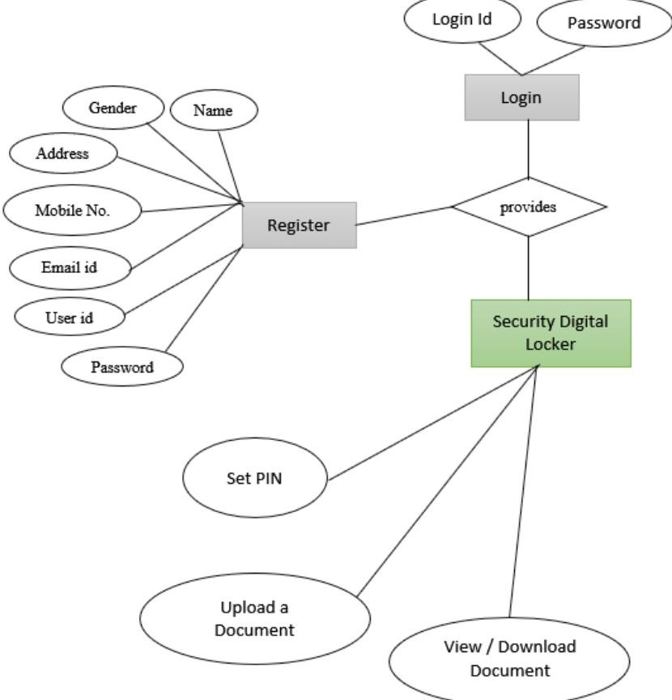

Figure 4.1 ER Diagram

Use Case Diagram

Use case diagram that describes the dynamic behavior of the application system. Dynamic behavior means the behavior of the application system when it is running. The use case diagram is active. There should be some internal or external factors for making the interaction. These internal and external agents are known as actors. So, use case diagrams consist of actors, use cases and their relationships.
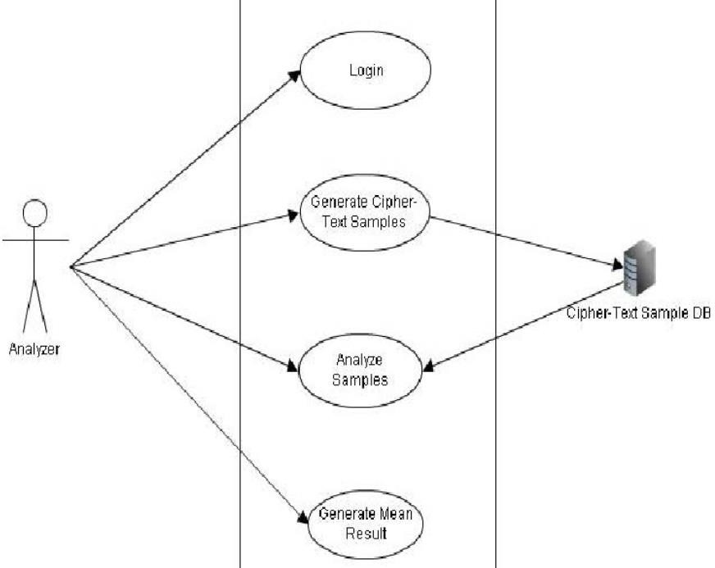

10

Figure 4.2 Use Case Diagram

Sequence Diagram

A Sequence diagram is an interaction diagram that shows how objects interact with one another with a sequence of messages exchanged among them. It is a construct of a Message Sequence Chart. A sequence diagram shows object interactions arranged in a time sequence. It depicts the objects and classes involved in the scenario and the arrangement of messages exchanged between the entities needed to carry out the functionality of the scenario. Sequence diagrams are typically associated with use case realizations in the Logical View of the system under development. Sequence diagrams are sometimes called event diagrams or event scenarios. A sequence diagram shows parallel vertical lines (lifelines), different processes or objects that live simultaneously, and, as horizontal arrows, the messages exchanged between them, in the order in which they occur. This allows the specification of simple runtime scenarios in a graphical manner.

11

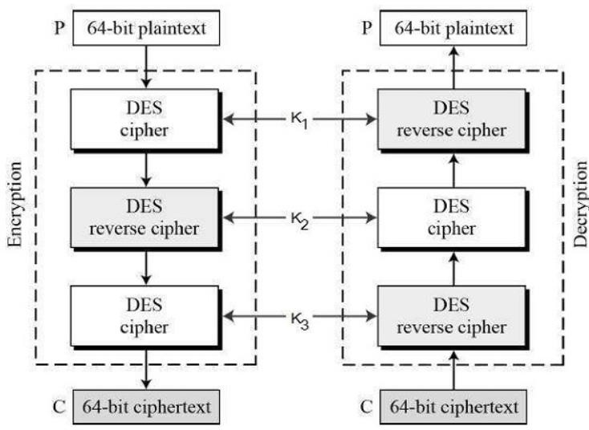

Figure 4.3 Sequence Diagram

Class Diagram

The class diagram provides an overview of the target system by describing the objects and classes inside the system and the relationships between them. It provides a wide variety of usages, from modeling the domain-specific data structure to the detailed design of the target system. With the shared model facilities, you can reuse your class model in the interaction diagram for modeling the detailed design of the dynamic behavior. The Form Diagram allows you to generate a diagram automatically with user-defined scope. To further describe the behavior of systems, these class diagrams can be complemented by a state diagram or UML state machine. For the current system classes in the domain of the system are extracted, and the relationship among those is decided by observing the “SRS” of the system. The class diagram is plotted with the following system description statement.
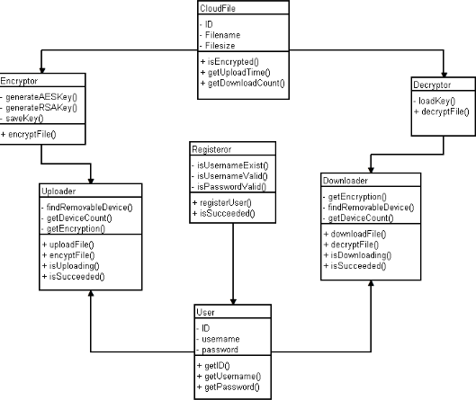

12

Figure 4.4 Class Diagram

4.4 SUMMARY
The chapter covers the design of the proposed system. The design is explained using, use case, sequence, and ER diagrams. This covers functional as well as a procedural model of the system.

13

CHAPTER FIVE

PROPOSED METHODOLOGY

5.1 Proposed Project Model

CONCLUSION
  - CONCLUSION

The project on securing digital images using Triple DES encryption demonstrates the practical application of cryptographic techniques to protect sensitive data in the form of images. By implementing a web-based solution using HTML, CSS, and JavaScript, we have created a user- friendly interface that allows users to encrypt and decrypt images with ease. The integration of the crypto-js library has facilitated the implementation of the Triple DES algorithm, ensuring robust security for the images processed by the system.

Throughout the project, we have highlighted the importance of using strong encryption keys and adhering to best practices in cryptographic implementations. The project successfully meets the objectives of providing a secure method for image encryption and decryption, emphasizing the usability and accessibility of the system for end users.

FUTURE SCOPE

While the current implementation provides a solid foundation for image security using Triple DES, there are several areas for future enhancement and expansion:

Enhanced User Authentication:
      - Implement user authentication mechanisms to ensure that only authorized users can access the encryption and decryption functionalities.
      - Consider integrating multi-factor authentication (MFA) to add an extra layer of security.

Support for Additional Cryptographic Algorithms:
      - Extend the system to support other encryption algorithms, such as AES (Advanced Encryption Standard) and RSA (Rivest-Shamir-Adleman), providing users with more options for securing their images.

Improved Key Management:
      - Develop a secure key management system to handle the generation, storage, and retrieval of encryption keys.
      - Explore the use of hardware security modules (HSMs) or secure key storage solutions to enhance key protection.

Batch Processing of Images:
      - Add functionality to process multiple images at once, making the system more efficient for users who need to encrypt or decrypt

REFERENCES
      - Attanas, D.B. and Monica, H.G. (2012). Effects of green house gases, In Proc. IOOC-ECOC, pp. 557-998.

      - Gurudeep, P.R. and Mahin, P. (2009). Risk sensitive estimation model II.
IEEE Transactions on Automatic Control, 43 (15): 355 - 363.

      - Prakas, K. (2011). Feedback and optimal sensitivity: Model reference transformations, multiplicative seminorms, and approximate inverses. IEEE Transactions on Automatic Control, 26(2): 301–320

      - Ram, R., Krishna, S. and Peter, K. (2005a). Risk sensitive estimation and a differential game. IEEE Transactions on Automatic Control, 39(9): 1914– 1918.

      - Ram, R., Krishna, S and Peter, K. (2005b). Differential rectification using control points. IEEE Transactions on Geoscience and Remote sensing, 55: 914 – 918.

      - Singh, K. and Robin, R. (2008). A linear- quadratic game approach to estimation and smoothing. In American Control Conference, New York. June 20 – 25, 2008, pp. 2818–2822.

Online Links:

Cryptography Stack Exchange
  - Cryptography Stack Exchange
  - A community-driven Q&A site where you can find discussions and answers related to cryptography, including Triple DES.

GeeksforGeeks
  - GeeksforGeeks Cryptography
  - Tutorials and articles on cryptography concepts and implementations.

27

